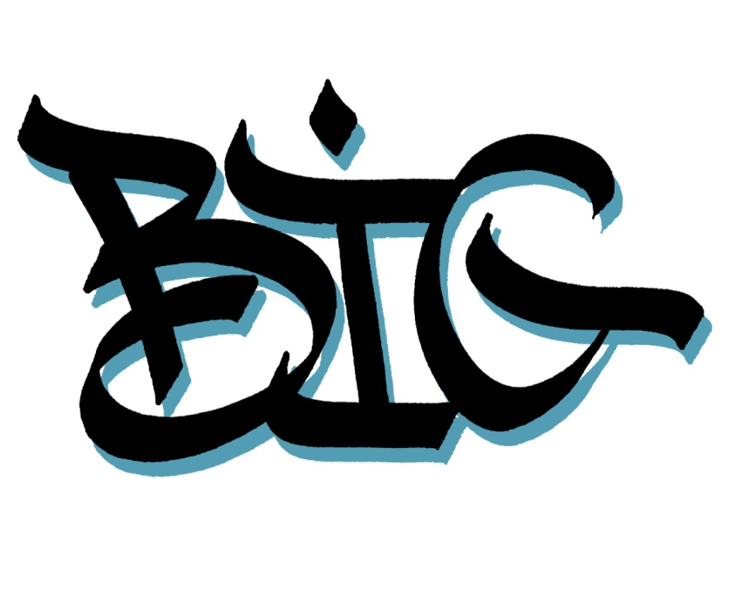
International Graffiti Battle

Sunday 24th November 2013
Lille – Halle de Glisse (Marquillies street)

Inscription modality :

People who want to participate to the B.I.G. must fill this inscription form and return it by mail with the pictures at : aerawsoulprod@gmail.com Before 4 November 2013.
The Inscription is free.
After examinig all the candidacies, the selected teams will receive an email with the necessary information to validate the inscription.

Information :

Firstname/lastname :….…………………………………………… ………………………
Adress :………………………………………………………………………………………
email :………………………………………………………………………………...
phone :……………………………………………………………………………………

Cities of origin: ………………………………………………

Website :………………………………………………………………………………….

Facebook / flickr / tumblr… : ……………………………………………………………………………………..

Thank for sending an email to : aerawsoulprod@gmail.com with :

- The filled form
- 4 pictures of pieces realised by you alone.

*Inscription before 4 November 2013.

The selected teams will receive an email with all the necessary information.

Sending an incomplete file or including mistakes will eliminate the concerned team.

